**California State University, Northridge**

**College of Engineering & Computer Science**

**Electrical and Computer Engineering Department**

**ECE 443L Digital Electronics Laboratory Report 10**

**P**

**By Haroutun Haroutunian**

**10.3 Simulation and Experimental Result**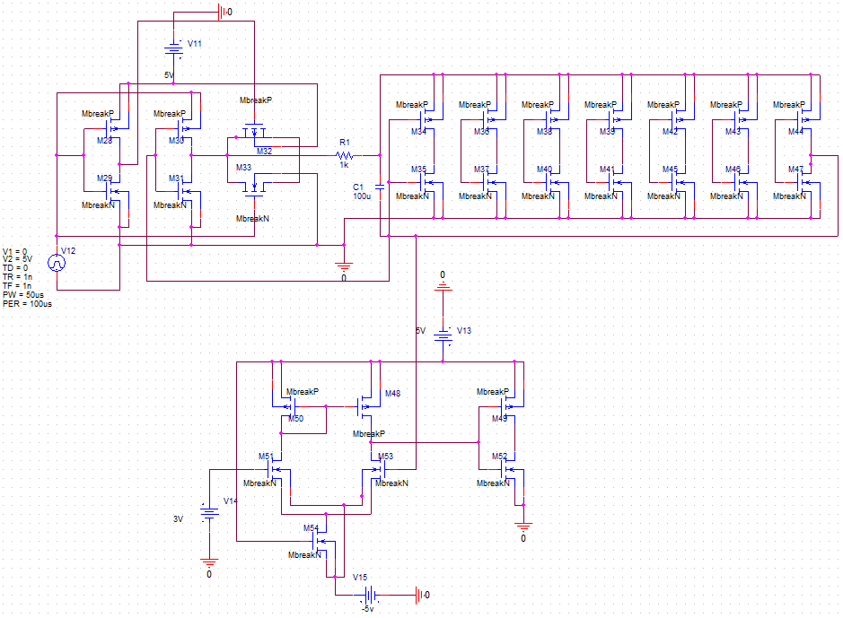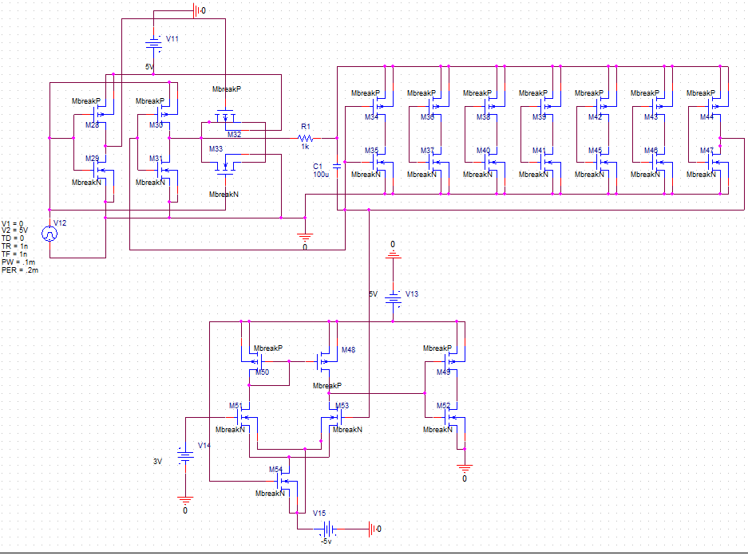

**Figure 10.1 Case 2 Haroutun Phase Lock Loop running at 10kHz schematic**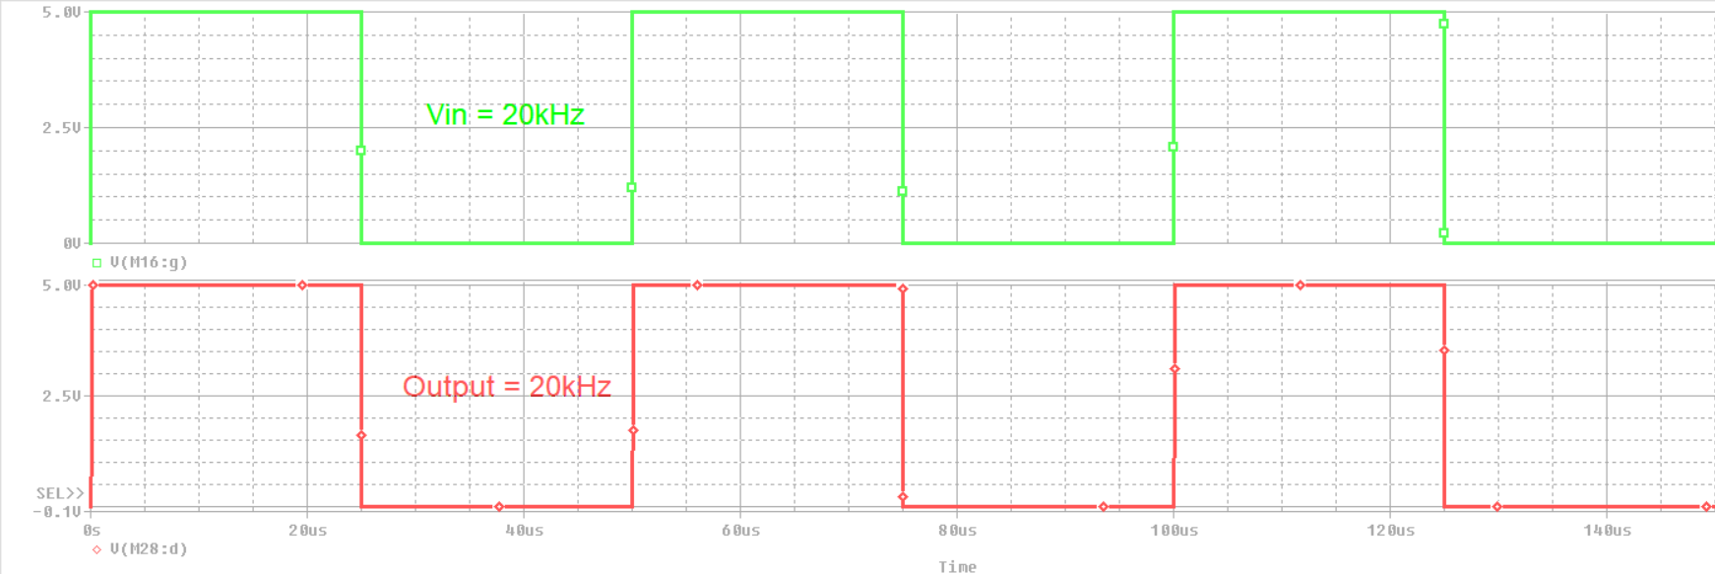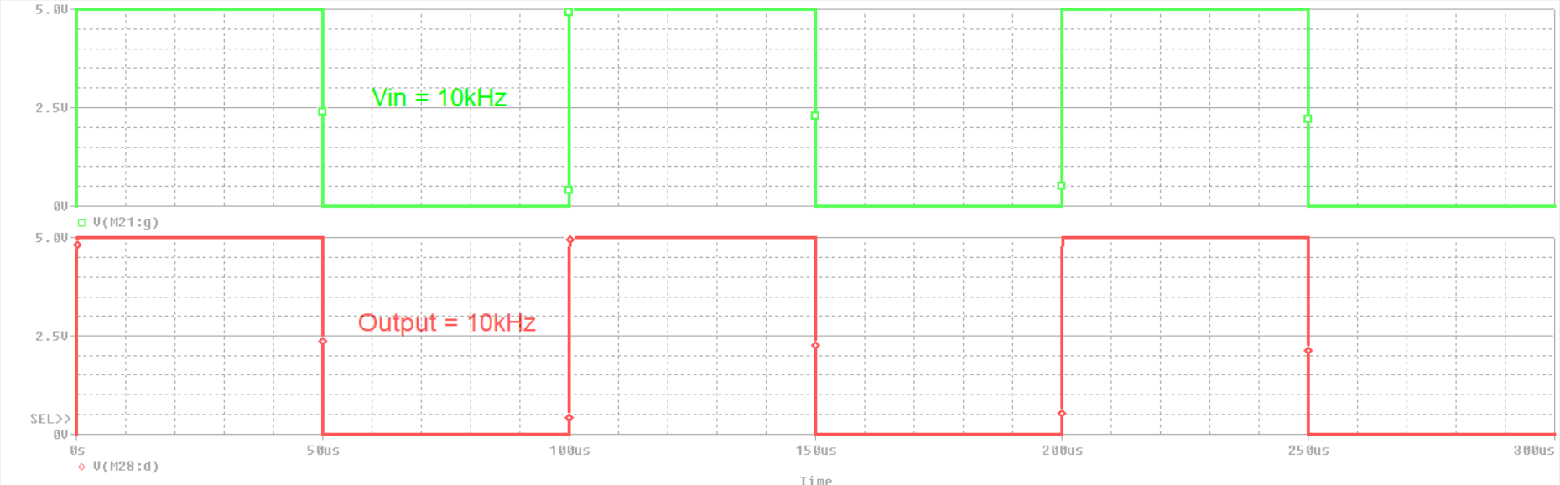

**Figure 10.2 Case 2 Haroutun Phase Lock Loop @ 10kHz waveform**

**Figure 10.3 Case 4 Haroutun Phase Lock Loop running at 20kHz schematic**

**Figure 10.4 Case 4 Haroutun Phase Lock Loop @ 20kHz waveform**